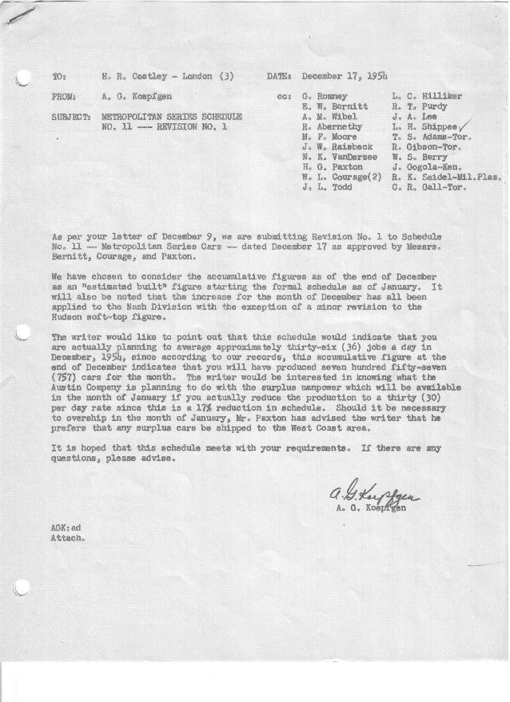

FORM PLAN 68 REV. 9-40-N.K.P PRINTED IN U.S.A

SCHEDULE NO. ______11________ DATE November 30, 1954 MONTHLY BUILDING SCHEDULE APPROVED E. W. Bernitt & J. W. Raisbeck (signed)___DATE_ 12-20-54____ REVISION NO. _______1________ DATE December 17, 1954___ PRODUCT APPROVED_____W. L. Courage (signed) ___________DATE_ 12-20-54____
METROPOLITAN SERIES CARS – AUSTIN MOTORS C. LTD., ENGLAND
DESCRIPTION | BUILT  ◻ACT EST  THRU  12-31-54 | FIRM BUILDING SCHEDULE  (FABRICATED MATERIAL RELEASE) |  |  |  |  |  |  |  |  |  |  |  |  |  |  | TENTATIVE SCHEDULE  (RAW MATERIAL RELEASED) |  |  | GRAND  TOTAL
DESCRIPTION | BUILT  ◻ACT EST  THRU  12-31-54 | MONTH January  DAYS 21 |  |  | MONTH February  DAYS 20 |  |  | MONTH March  DAYS 23 |  |  | MONTH April  DAYS 18 |  |  | MONTH May  DAYS 20 |  |  |  |  |  | GRAND  TOTAL
DESCRIPTION | BUILT  ◻ACT EST  THRU  12-31-54 | DAILY | MONTH | CUM’L  TOTAL | DAILY | MONTH | CUM’L  TOTAL | DAILY | MONTH | CUM’L  TOTAL | DAILY | MONTH | CUM’L  TOTAL | DAILY | MONTH | CUM’L  TOTAL | DAILY | MONTH | TOTAL | GRAND  TOTAL
NASH
Hard-Top Conv. | 7550 |  | 230 | 7780 |  | 366 | 8146 |  | 575 | 8721 |  | 460 | 9181 |  | 511 | 9692
Soft-Top Conv. | 3802 |  | 0 | 3802 |  | 119 | 3921 |  | 172 | 4093 |  | 115 | 4208 |  | 152 | 4360
Total | 11352 |  | 230 | 11582 |  | 485 | 12067 |  | 747 | 12814 |  | 575 | 13389 |  | 663 | 14052
HUDSON
Hard-Top Conv. | 2414 |  | 400 | 2814 |  | 334 | 3148 |  | 322 | 3470 |  | 242 | 3712 |  | 254 | 3966
Soft-Top Conv. | 312 |  | 0 | 312 |  | 81 | 393 |  | 81 | 474 |  | 83 | 557 |  | 83 | 640
Total | 2726 |  | 400 | 3126 |  | 415 | 3541 |  | 403 | 3944 |  | 325 | 4269 |  | 337 | 4606
CORPORATION TOTAL
Hard-Top Conv. | 9964 | 30 | 630 | 10594 | 35 | 700 | 11294 | 39 | 897 | 12191 | 39 | 702 | 12893 | 38 | 765 | 13658
Soft-Top Conv. | 4114 | 0 | 0 | 4114 | 10 | 200 | 4314 | 11 | 253 | 4567 | 11 | 198 | 4765 | 12 | 235 | 5000
Grand Total | 14078 | 30 | 630 | 14708 | 45 | 900 | 15608 | 50 | 1150 | 16758 | 50 | 900 | 17658 | 50 | 1000 | 18658
Over/(Under) Sched. #10 | 31 |  | 0 | 31
 |  | Month: | June |  | Month: | July
 |  | Days: | 22 |  | Days: | 5
NASH
Hard-Top Conv. |  |  | 707 | 10399 |  | 81 | 10480
Soft-Top Conv. |  |  | 0 | 4360 |  | 0 | 4360
Total |  |  | 707 | 14759 |  | 81 | 14840
HUDSON
Hard-Top Conv. |  |  | 393 | 4359 |  | 161 | 4520
Soft-Top Conv. |  |  | 0 | 640 |  | 0 | 640
Total |  |  | 393 | 4999 |  | 161 | 5160
CORPORATION TOTAL
Hard-Top Conv. |  | 50 | 1100 | 14758 | 50 | 242 | 15000
Soft-Top Conv. |  | 0 | 0 | 5000 | 0 | 0 | 5000
Grand Total |  | 50 | 1100 | 19758 | 50 | 242 | 20000

